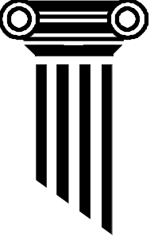
One old Greek

For this task you will need:
Card
Sharp pencil
Ruler
Scissors
Protractor

The constructions in this task require great accuracy. Make sure that all your work is as neat as possible.

Task 1

- On the card, draw two rectangles 3cm by 4cm.
- On each rectangle draw in one diagonal line, creating four triangles in total.
- Carefully cut out these four triangles.
- What type of triangles have you created? Measure the length of the long side. What is the special name given to the longest side of this particular type of triangle?

- On the card, draw three squares with sides of length 3cm, 4cm and 5cm.
- Carefully cut out your three squares.

You should now have seven shapes as shown below.
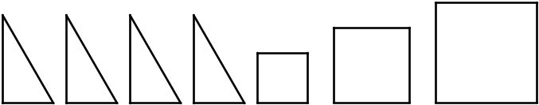

Task 2

- In your exercise books, draw two squares of side 7cm
- Arrange the four triangles and the largest square within the first of these, so that they fit exactly. Draw your arrangement.
- Now arrange the two smaller squares and the four triangles so that they fit exactly within the second of these squares.
- What does this tell you about the areas of your three cut out squares? (HINT: Compare the largest against the smaller two)

Task 3

What famous theorem does this remind you of? Find out what the theorem is exactly.
Explain when and how you could use this theorem.

Try the task again with rectangles of 5cm by 12cm, and squares of side 5cm, 12cm and 13cm. Does the same thing happen?

